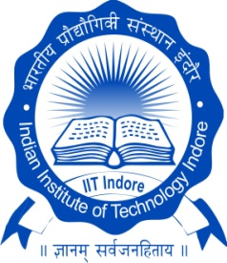

भारतीय प्रौद्योगिकी संस्थान इंदौर

**Indian Institute of Technology Indore**

**Overview**

* Inception in 2009.
* 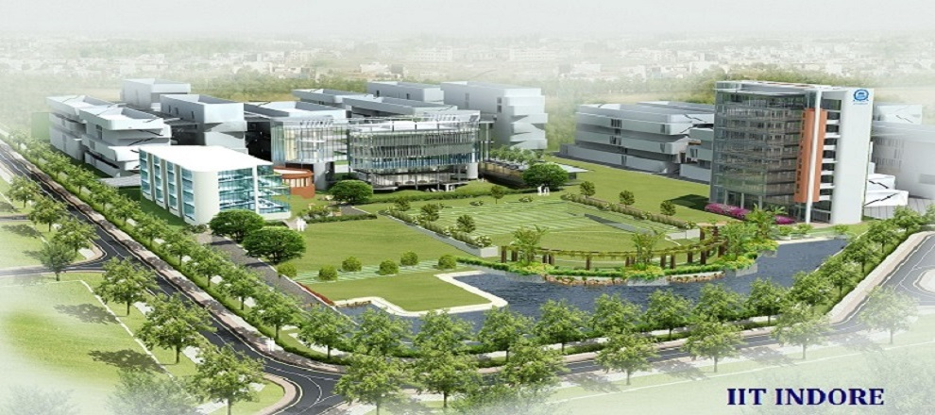1840+ students in UG, PG and Ph.D. programmes*.
* Multi-disciplinary focus and foreign qualified faculty members.
* More than 60 state-of-the-art Teaching and Research Laboratories.
* 13th rank in Engineering Category in Indian Government, NIRF Ranking 2019.
* 3rd rank in India under Times Higher Education Ranking, 2019
* Leading from the front (e-vehicles to commute within the campus, cashless campus, etc.).
* Highest number of foreign faculty short courses (GAIN) conducted per IIT Indore faculty (amongst all institutions).

**\*Data provided as of March 2020**

**Academic Programmes**

|  |  |  |  |  |
| --- | --- | --- | --- | --- |
| **Bachelor of Technology**  **(B.Tech.)** | * **Civil Engineering (CE)** * **Computer Science and Engineering (CSE)** * **Electrical Engineering (EE)** * **Mechanical Engineering** * **Metallurgy Engineering and Materials Science (MEMS)** | | | |
| **Master of Technology**  **(M.Tech.)**  **Also Available**  **a) B.Tech. + M.Tech.**  **b) M. Tech. + Ph.D.** | * **Communication and Signal Processing, EE** * **VLSI Design and Nanoelectronics, EE** * **Mechanical System Design, ME** * **Production and Industrial Engineering, ME** * **Materials Science and Engineering, MEMS** * **Metallurgy Engineering, MEMS** | | | |
| **Master of Science - Research**  **(M.S. Research)** | * **CSE** * **EE** * **ME** | | | |
| **Master of Science**  **(M.Sc.)**  **Also Available M.Sc. + Ph.D.** | * **Astronomy, Astrophysics and Space Engineering (AASE)** | | * **Bio Sciences and Biomedical Engineering (BSBE)** | |
| * **Chemistry** | * **Mathematics** | | * **Physics** |
| **Ph.D.** | * **AASE, BSBE, CE, CSE, EE, ME, and MEMS** * **Chemistry, Mathematics and Physics** * **Economics, English, Philosophy, Psychology and Sociology** | | | |

**Research**

* Focus on interdisciplinary education and research.
* Highest numbers of citations and h-index among all new IITs.
* **P**romotion of **R**esearch and **I**nnovation amongst **U**ndergraduate **S**tudents (PRIUS)-a unique IIT Indore initiative to foster research culture among UG students.

Citations & h-index

* Faculty members listed amongst highly prolific authors by *Current Science.*
* 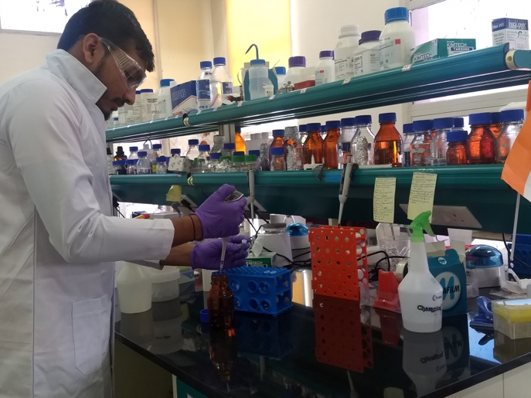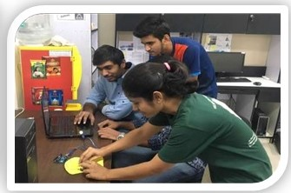****Externally sponsored research projects worth over USD 14.9 millions (INR 1053 Millions).

** International Collaborations**

**Germany and France**

* Collaborations with TU9 universities in Germany including six MoU.
* Fifteen joint-publications and ten on-going joint-projects in the past few years with seven TU9s.
* Around thirty bilateral visits by faculty members and students of IIT Indore and TU9 universities.
* Joint research work with fifteen institute in France, including a Visiting Advanced Joint Research (VAJRA) faculty.
* Active consultation and engagements including MoU with IMTs.

**Other Countries**

* Collaboration with countries across Americas, Europe and Asia-Pacific.
* ****More than thirty active MoU with foreign universities.
* Hosted number of international internship and exchange students.

**Industry Relations, Innovation and Entrepreneurship**

* Organize annual Industry Academia Conclave to invigorate efforts towards joint ventures and partnerships.
* Organize annual TEDx events to inspire, galvanize and orient students towards their goals.

**Industry Relations (IR) Few Sponsors**



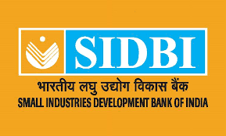

**Incubation and Entrepreneurship (IE) Few Startups**

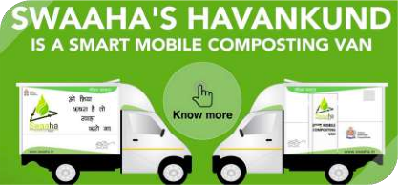

**Innovation and Entrepreneurship Development Centre (IEDC)**

* Support India’s socio-economic development with vision to make faculty “entrepreneurial”.
* Support on-campus student activities and student entrepreneurial ideas through Student Entrepreneurship Support Cell (SESC).
* Conduct annual e-Summit.

**The Future**

* Harness technology to address real life challenges.
* Be amongst top 200 institutes of the world in next 5 years.
* Create a sustainable green campus and promote it externally.



भारतीय प्रौद्योगिकी संस्थान इंदौर

**Indian Institute of Technology Indore**

Khandwa Road, Simrol, Indore MP - 453552, India

Email- [intloffice@iiti.ac.in](mailto:intloffice@iiti.ac.in)